Meadowlawn Messenger

Behavior Skill of the Month:

Responsibility

Friday, Oct. 4, 2019

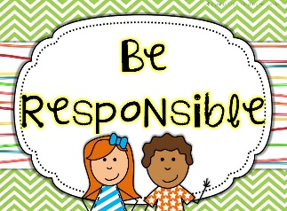

 **Principal: Tim Hargis**

**School Day: 9:00am-3:52pm**



**Upcoming Events:**

**Oct. 9 ~** PTC meeting @ 6-7pm

**Oct. 11** ~ Picture Retake Day

**Oct. 25** ~ 5th gr. STEM event 9-11:30am

**Week of Oct. 28 – NO ARCH**

**Oct. 28 ~ Full Day**

**Oct. 29 ~ Full Day;** Parent Teacher Conf. 4-8pm

**Oct. 30** ~ **½ Day**; **12:03pm Dismissal**; 1-8pm

Parent Teacher Conferences

**Oct. 31** ~ **½ Day**; Fall Harvest Parade @ 10:45am

**12:03pm Dismissal**

**Nov. 1** ~ **½ Day; 12:03pm Dismissal**

**Nov. 5 ~** 4th gr. Field Trip

**Nov. 8 ~** K & 1st gr. Field Trip

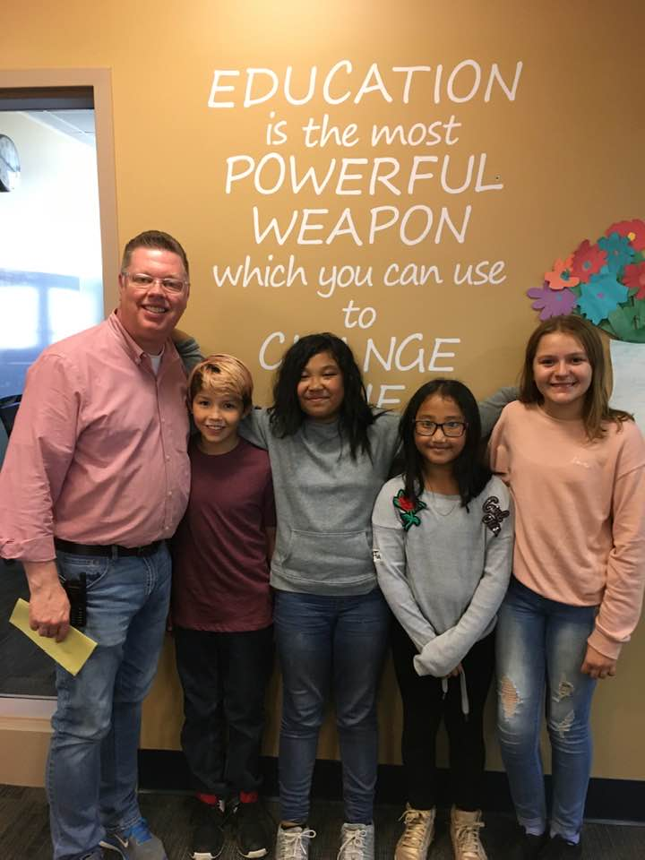





Picture Retakes Friday, Oct. 11

President = Matthew J  
Vice President = Eiei M  
Secretary = Naomi P  
Treasurer = Sedina S



**5th Grade** = May 13

**K-4th** = May 27 (also school picnic)



**Counselor’s Corner**



**October 31**

**10:45-12:03pm**

**Fall Harvest Parties**

We will start with a parade outside (weather permitting) at 10:45am. Students should wear their costumes to school, if possible.

To keep the focus positive, we ask that you adhere to the following guidelines:

* Children’s costumes should be non-violent. Toy weapons such as axes, swords, knives and guns are not allowed at school.
* Keep costumes simple and be creative.
* **A Written Note must be given to the teacher, if you do not want your child to participate in the Fall Harvest Party.**

Turn Your Word Into Gold    *By Jim Fay*

|  |  |
| --- | --- |
| **Ineffective Technique** | **Love and Logic Technique** |
| Please sit down. We're going to eat now. | We will eat as soon as you are seated. |
| Please be quiet. I can't listen to your brother when you are both talking at the same time. | I'l be glad to listen to you as soon as your brother has finished talking to me. |
| Clean your room so we can go shopping. | I'll be happy to take you shopping as soon as your room is clean. |
| I'm not going to play ball with you until all of you are quiet. | I'll be happy to play ball with you as soon as it is quiet. |
| Don't talk while I'm reading to you. | I will start reading to you again as soon as you have finished talking. |
| You can't go play until you have finished your homework. | Feel free to go play as soon as you have finished your homework. |
| Don't shout at me. | I listen to people who do not yell at me. |
| Pay attention. | I'll start again as soon as I know you are with me. |



**Schedule for Conference Week:**

Monday, October 28

Full Day of School - No ARCH

Tuesday, October 29

Full Day of School - No ARCH

Conferences 4:00-8pm

Wednesday, Oct. 30

1/2 Day of School - No ARCH; 12:03pm Dismissal

Conferences 1:00-8pm

Thursday, Oct. 31

1/2 Day of School - No ARCH; 12:03pm Dismissal

Friday, November 1

1/2 Day of School - No ARCH; 12:03pm Dismissal



**The Counselor, Kristi Sherrington, will be available during conferences from 4:30-8pm on Wednesday, Oct. 30.**

**`**

